**IT 166 Assignment 1 (40 points)**

**Due date: September 2nd at 11:55 PM**

Download the Python script, assignment1.py and provide solutions to the problems.

Expected outcome:

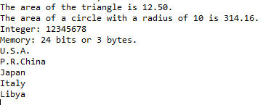

Problem 5 (10 points):

Given a math function: $f\left(x\right)=x^{3}+2x^{2}+5$

Use Python statements to show that the close-form solution of the first order derivative of $f\left(x\right)$, which is $f^{'}\left(x\right)=3x^{2}+4x$, is approximately equal to the numeric solution of $f^{'}\left(x\right)=\frac{f\left(x+h\right)-f(x)}{h}$ when $x=7$ and h is small.

Requirements:

1. Your program display should exactly match the expected outcome.
2. For problem 1, you are required to use string formatting expressions.
3. For problem 2, you are required to use string format method. For problem 2’s display, you should not hard-code the radius. Make sure if the radius changes, the area also changes.
4. For problem 3, there is a method that returns the number of bits for the target value.
5. For problem 4, you are required to use the string methods or string slicing to solve the problem. You should not hard-code the information, such as print (“U.S.A.”)
6. For problem 5, you will need to print out two values of $f^{'}\left(7\right)$, one is obtained using the close-form solution and the other one is obtained using the numeric solution. These two values should be close.
7. Submit your solution on ReggieNet.